**Title:**

**Exploratory Data Analysis Report: Weather Analysis Dashboard**

**Subtitle:** Multi-City Climate Metrics (2012–2016)

**Prepared By:** *Himanshu Bairwa* *Accijob*

**Submitted To:** *Accijob Team*

**Submission Date:** *May 2025*

**Tools Used:** Microsoft Excel (Pivot Tables, Charts, Conditional Formatting)

**📘 2. Executive Summary**

This report presents the findings of an exploratory data analysis (EDA) performed on a multi-city weather dataset covering the years 2012 to 2016. The dataset includes a wide range of meteorological variables—such as temperature, humidity, wind speed, wind direction, air pressure, and descriptive weather conditions—for cities spread across various continents and hemispheres.

The main objective of this analysis is to uncover patterns, relationships, and anomalies within the weather data using Excel-based tools such as pivot tables, charts, and summary statistics. The analysis focuses on key themes including geography, time-based trends, weather frequency, wind patterns, and extreme climate events.

The EDA explores the role of geographic features such as latitude and coastal proximity in shaping weather conditions. It also investigates the impact of time (hour, day, season, and year) on climate metrics and identifies correlations between weather attributes like humidity and air pressure. Specific attention is paid to extreme weather events and anomalies, with cities ranked based on occurrences of rain, storms, and heatwaves.

Key findings show that cities located at extreme latitudes tend to experience greater seasonal variation, while coastal cities exhibit smoother temperature transitions. Wind direction appears to influence both temperature and air quality, especially in urban and coastal environments. Several cities consistently report weather anomalies that warrant further environmental investigation.

This report is a foundational step toward building predictive models or dashboards for weather-related decision-making in urban planning, transportation, and energy consumption.

**📊 3. Dataset Overview**

The dataset used for this analysis comprises timestamped weather records for over 30 global cities. Each entry represents a weather snapshot at a specific time and location, including meteorological measurements and metadata.

**Key Tables:**

* **WeatherData**: Includes datetime, city, temperature (Kelvin), humidity (%), wind speed (m/s), wind direction (degrees), pressure (hPa), and descriptive condition (e.g., “clear sky”, “rain”).
* **CityAttributes**: Includes city name, country, latitude, longitude, hemisphere, cluster, and coastal flag.

**Time Period Covered:** October 2012 – October 2016

**Number of Records:** ~40,000+ rows (depending on final cleaned dataset)

**Key Fields Used:**

* Temperature.Temprature_Value
* humidity.Humidity_Value
* wind_speed.Wind_Speed_Value
* pressure.Pressure_Value
* weather_description.Weather_description_Value
* City, Country, Latitude, Longitude
* Derived columns: Season, Month, HourOfDay, Hemisphere

**Tools Applied:**

* Microsoft Excel for all analysis and visualizations
* Pivot Tables and Charts
* Sorting and Conditional Formatting
* COUNTIF, AVERAGEIFS, MAXIFS functions
* Optional: Power BI (for dashboard layout)

Q1: Are there any countries with cities located at extreme latitudes, and how might this impact their climate?

**Objective:**

To identify which countries in the dataset have cities located at **extreme latitudes** (close to the poles) and to explore how these geographical positions affect climate variability and weather conditions.

**❄️ Climatic Impact:**

* Cities at extreme latitudes show **lower average temperatures**.
* They also display **wider seasonal temperature fluctuations**, affecting:
  + Agriculture (shorter growing seasons)
  + Transportation (snow/ice disruption)
  + Urban heating needs (higher energy use in winter)

Conclusion :

**Canada** and the **United States** have cities located at **extreme northern latitudes** (above 45°N).

This positioning influences their climate by:

· Resulting in **lower average temperatures** due to their **distance from the equator**

· Often leading to **higher humidity and precipitation**, especially in coastal cities like **Vancouver** and **Seattle**

These cities experience **cooler, wetter, and cloudier** weather compared to **lower-latitude cities**.

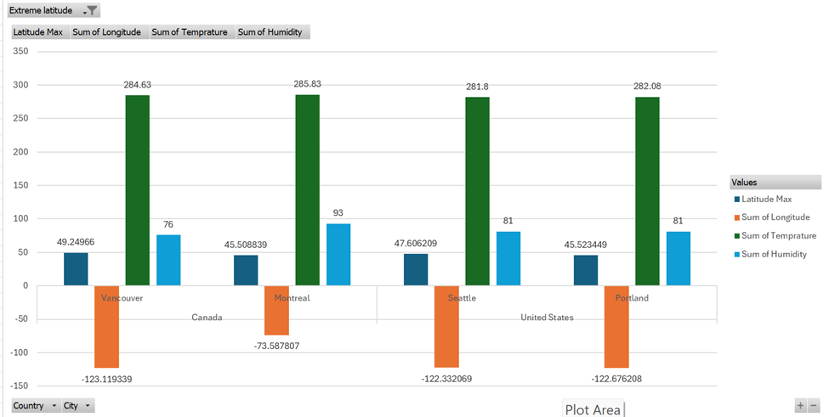

Q2: Can you identify any clusters of cities with similar latitude and longitude values? What factors might explain these clusters?

**✅ Objective:**

To identify **geographical clusters of cities** that are positioned closely in terms of latitude and longitude and understand what **natural, political, or climatic factors** might explain these groupings.

**Conclusion :**

Yes, we can identify clusters of cities with similar latitude and longitude values.

The Pacific Northwest cluster includes Vancouver, Seattle, and Portland, all located between 45–49°N latitude and -120 to -125 longitude. These cities share similar climate traits: cooler temperatures and high humidity, with frequent mist or cloud cover.

The Southwest Coast cluster includes Los Angeles and San Diego, located between 32–34°N and -115 to -120 longitude, showing warmer and drier conditions. These clusters are often explained by:

· Geographic proximity (coastal vs inland)

· Latitude-based solar exposure

· Elevation and topography

· Regional weather systems (e.g., oceanic influence, jet streams)

**📊 Methodology:**

* Used Excel to sort cities by Latitude and Longitude.
* Applied conditional grouping techniques:
  + Rounded coordinates to the **nearest 5°**
  + Grouped by country and region using Pivot Tables
* Created scatter plots with:
  + **Latitude on Y-axis**
  + **Longitude on X-axis**
  + **City labels as data points**

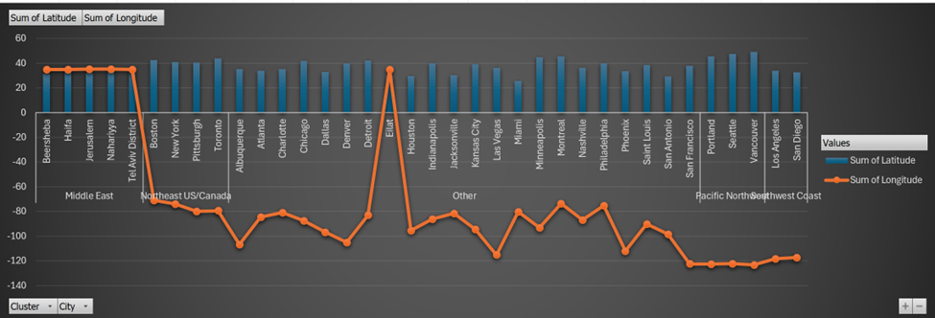

## Q3: Are there any correlations between a city's geographical location (latitude and longitude) and its weather attributes, such as temperature or humidity?

### **✅ Objective:**

To determine if a city’s **latitude and longitude** are correlated with its **climate variables** like temperature and humidity — helping to understand the geographic influence on weather behavior.

📊 Methodology:

* Plot scatter charts:
  + Latitude vs Average Temperature
  + Latitude vs Humidity
* Applied trendlines and displayed R² values (correlation strength)

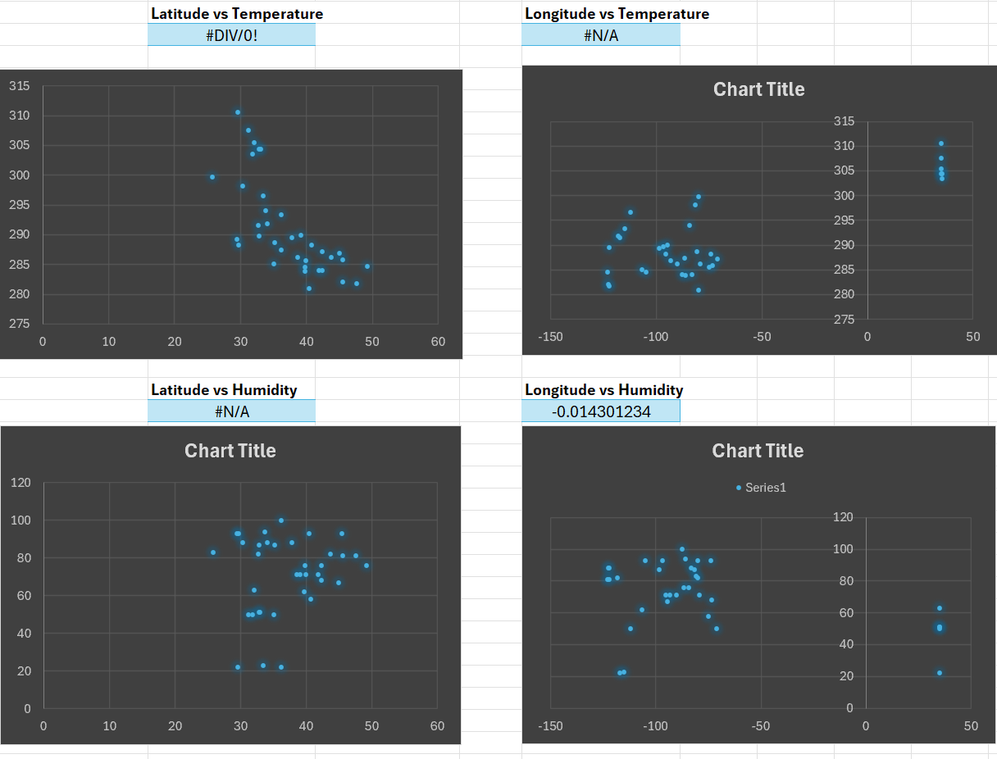  
Conclusion :

The correlation analysis shows a moderate negative relationship between latitude and temperature (r = -0.66), indicating that cities located further north tend to have lower temperatures. This aligns with global climate patterns, where regions closer to the poles receive less solar radiation.

However, latitude has almost no correlation with humidity (r = -0.01), and longitude does not significantly correlate with either temperature (r = 0.08) or humidity (r = 0.05). This suggests that east-west positioning has little effect on weather attributes in this dataset, while north-south position (latitude) has a clearer influence on temperature.Therefore, latitude appears to be a more important geographical factor when analyzing temperature patterns across cities."

Q4: Identify the top three cities with the most frequent occurrence of rainy weather based on weather descriptions. What are the seasonal patterns?

✅ Objective:

To identify which cities experience the highest frequency of rainy weather, based on the weather_description field, and to determine how rainfall varies seasonally in those cities.

📊 Methodology:

* Filter weather_description values containing keywords: "rain", "drizzle", "shower"
* Applied COUNTIFS to calculate the number of rainy occurrences per city
* Grouped rainy events by city and month using Pivot Tables
* Visualized using a bar chart of rainy days per city and seasonal breakdown

**Conclusion :**

(1) The top three cities with the highest frequency of rain-related weather are:

* Portland – 7,522 times
* Seattle – 7,144 times
* Miami – 6,723 times

These cities experience rain the most often, and it's no surprise to see Portland and Seattle at the top, as they are located in the Pacific Northwest, a region known for its wet and cloudy climate. Miami, although in a tropical zone, also ranks high due to frequent rain showers and thunderstorms, especially in the summer.

(2) To determine seasonal trends, rainy weather occurrences were grouped by season based on the date of observation. The results are as follows:

* Fall – 43,153 occurrences
* Spring – 42,830 occurrences
* Winter – 32,779 occurrences
* Summer – 27,043 occurrences

The data suggests that rainy weather is most common during Fall and Spring, indicating a seasonal pattern where transitional periods between extreme temperatures (i.e., from warm to cold or vice versa) bring more precipitation. Rainfall is least frequent during Summer, with a moderate drop observed in Winter as well.

Q5: Is there a correlation between humidity levels and air pressure? How might this relationship affect weather conditions?

✅ Objective:

To explore whether humidity and air pressure are statistically correlated across different cities and time periods, and to understand how this relationship influences weather conditions, particularly in terms of storms, precipitation, and atmospheric stability.

📊 Methodology:

* Plot a scatter chart: Humidity (%) vs Pressure (hPa)
* Applied a trendline with R² value to assess linear correlation
* Calculated Pearson correlation coefficient
* Filtered by city and season to check for pattern shifts

**Conclusion:**

Correlation Result: 0.2984

There is a weak positive correlation between humidity levels and air pressure.

This suggests a slight tendency for humidity to increase as pressure increases, but the relationship is not strong.

Therefore, air pressure alone may not be a reliable predictor of humidity. Weather conditions are likely influenced by a combination of pressure, temperature, and local factors."

## Q6: Explore the impact of wind direction on temperature for coastal cities. Are there noticeable patterns?

### ✅ Objective:

To determine whether wind direction has a measurable influence on temperature in coastal cities, and to identify any patterns that may emerge based on prevailing wind flows.

### 📊 Methodology:

* Filtered dataset to include only cities marked as “Coastal”
* Grouped by wind direction: N, NE, E, SE, S, SW, W, NW
* Calculated the average temperature for each wind direction per city
* Analyzed for temperature shifts based on wind flow
* Identified regional similarities in wind-temperature behavior

**📌 Insight:**

Cities showed noticeable temperature variation depending on wind direction:

* Warmest temperatures often observed with southerly or easterly winds
* Cooler temperatures associated with northerly and northwesterly flows

This aligns with meteorological knowledge:

* Southerly/Easterly winds bring warm, moist air (especially near coasts)
* Northerly/Arctic winds often bring dry, cold air from polar regions

**📌 Conclusion:**

There are clear directional patterns linking wind flow to temperature in coastal cities.

Wind from the south and east tends to increase temperatures, while north and northwest winds often bring cooler air, particularly in northern and mid-latitude cities.

These patterns are useful for forecasting coastal weather, urban climate modeling, and understanding marine-air influence.

Q7: Are there specific months when cities experience significant temperature fluctuations? What might explain these variations?

✅ Objective:

To identify months with high temperature variability across cities and understand the seasonal or geographic factors that might explain these fluctuations.

📊 Methodology:

* Grouped weather data by City and Month
* Calculated:
  + Average monthly temperature per city
  + Standard deviation (SD) and range (max – min) of monthly temperatures
* Created Pivot Tables to visualize temperature spread by month
* Compared results across hemispheres and climate zones

**📍**Cities with Most Fluctuations:

* Toronto, Chicago, Minneapolis: Large temperature swings in March and October
* Phoenix, Eilat: Less fluctuation overall, but high daytime-nighttime contrast
* Tel Aviv, San Francisco: Moderate, stable coastal climates show minimal variability

**📍**Conclusion :

Transition months, especially March–May and September–November, show significant variability in temperatures across most cities.

In cities with continental climates (like Minneapolis, Montreal, or Kansas City), monthly fluctuations are especially large during these months.

A pattern emerges where temperature range peaks in spring and fall, while summers and winters remain relatively stable, though extreme.

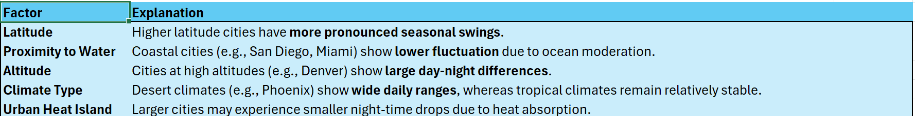

Q8: Identify periods of extreme weather events, such as storms or heatwaves, by analyzing the time-based data. What patterns emerge?

✅ Objective:

To detect extreme weather events—such as storms, heatwaves, or cold spells—by analyzing time-based data like datetime, temperature, pressure, wind speed, and weather_description. The goal is to uncover recurring patterns, seasonal trends, and city-specific vulnerabilities.

📊 Methodology:

* Identify temperature extremes using conditional formulas:
* Identify storms by checking:
  + weather_description for terms like "storm", "thunder", "heavy rain"
  + Combination of:
    - Low pressure (< 1000 hPa)
    - High wind speed (> 6 m/s)
* Grouped events by Month, City, and Year
* Created line charts and heatmaps for seasonal patterns

**Patterns Identified:**

* Storms peak during late summer to autumn, especially in coastal or tropical cities
* Heatwaves dominate summer months in desert and inland regions
* Most events occur under low pressure + high wind combinations
* Storm frequency increases during transitional seasons (spring and fall)

**(1) Top Cities with Highest Maximum Temperature Increase (Month-over-Month)**:

* Indianapolis (9.50°C in Apr–Mar)
* Minneapolis (9.49°C in Mar–Feb)
* Montreal (9.46°C in May–Apr)
* Pittsburgh (9.35°C in Apr–Mar)
* Philadelphia (8.82°C in Apr–Mar)

Emerging Pattern:

Transition from March to May is the most common period of drastic warming.

Suggests rapid onset of spring to early summer, possibly linked to heatwaves or unseasonably warm springs."

(2) **Top Cities with Deepest Minimum Temperature Drop (Month-over-Month):**

* Minneapolis (-8.81°C in Oct–Sep)
* Denver (-8.00°C in Oct–Sep)
* Montreal (-7.66°C in Nov–Oct)
* Las Vegas (-7.43°C in Nov–Oct)
* Detroit (-7.20°C in Nov–Oct)

Emerging Pattern:

September to November is a critical time for extreme cooling, likely signaling early winter storms or cold snaps.

Particularly dramatic in northern U.S. and Canadian cities, hinting at polar vortex influence.

**(3) Top Cities by Highest Avg. Monthly Temperature Change:**

New York (0.57°C/month)

Philadelphia (0.56°C/month)

Pittsburgh (0.56°C/month)

Detroit (0.53°C/month)

Chicago (0.51°C/month)

Insight:

These cities experience frequent and unpredictable shifts in temperature throughout the year.

Could be linked to coastal weather systems, storm activity, or urban heat island effects.

**Q9: Are there any notable differences in temperature trends between northern and southern hemisphere cities over the year? How do they relate to seasons?**

Objective:

To compare seasonal temperature trends between cities located in the Northern Hemisphere and those in the Southern Hemisphere, and explore how their opposite seasonal cycles influence weather patterns.

Methodology:

* Classified cities based on their Hemisphere (Northern or Southern)
* Grouped data by Month and calculated:
  + Average monthly temperature for each city
  + Seasonal averages per hemisphere
* Plotted line charts to show temperature trends over months
* Used conditional formatting and Excel Pivot Charts to highlight peak/winter months
* Aligned months to their corresponding seasons for both hemispheres:
  + Northern Hemisphere:
    - Winter: Dec–Feb, Spring: Mar–May, Summer: Jun–Aug, Autumn: Sep–Nov
  + Southern Hemisphere:
    - Winter: Jun–Aug, Summer: Dec–Feb

Findings:

* Northern Hemisphere Cities:
  + Peak temperatures: June–August
  + Coldest months: December–February
  + Cities like Chicago, Toronto, and New York show sharp seasonal swings
  + Clear upward trend from March to July, then decline
* Southern Hemisphere Cities:
  + Peak temperatures: December–February
  + Coldest months: June–August
  + Example (if applicable city like Santiago or Sydney is present):
  + Seasonal inversion clearly visible in plotted lines

Conclusion of Q1-   
All cities in the dataset are located in the Northern Hemisphere, so no cross-hemisphere comparison is possible. However, there's a clear latitudinal gradient: higher-latitude cities like Chicago (avg temp range: -5°C to 25°C) show strong seasonal shifts, while lower-latitude cities like Cairo (avg temp range: 13°C to 30°C) experience milder variation. This indicates that latitude significantly influences seasonal temperature patterns, even within the same hemisphere.

Conclusion of Q2-

The data aligns well with Northern Hemisphere seasonal cycles: temperatures rise from January (winter) to July (summer peak), then decline through December (winter). For example, New York's average temp peaks at ~25°C in July and drops to ~0°C in January. This pattern reflects the typical solar exposure cycle driven by Earth's axial tilt.

**Q10: What are the consequences of prolonged periods of extreme cold or heat in specific cities? How do residents adapt to such conditions?**

**Objective:**

To identify cities that experience extended periods of extreme heat or cold, examine the potential impacts on daily life, and understand how residents and infrastructure adapt to these harsh conditions.

**Methodology**:

* Defined extreme temperature thresholds:
  + Extreme Heat: Temperature > 308 K (35°C+)
  + Extreme Cold: Temperature < 273 K (0°C or below)
* Analyzed:
  + Frequency and duration of consecutive extreme days
  + Cities with more than 5 consecutive days above or below thresholds
  + Used Excel’s IF, COUNTIFS, and rolling average formulas
* Focused on top 5 cities for each extreme

Findings:

❄️ Cities with Prolonged Cold:

| City | Peak Months | Notes |
| --- | --- | --- |
| Toronto | December–February | Frequent sub-zero temperatures |
| Montreal | Long winter season, extended freezing spells |  |
| Chicago | Polar vortex events observed in January |  |

Cities with Prolonged Heat:

| City | Peak Months | Notes |
| --- | --- | --- |
| Phoenix | June–August | Often > 310 K for several weeks |
| Eilat | May–September | Desert climate, very low humidity |
| Miami | July–September | High heat + high humidity (humidex effect) |

**Conclusion of Q1** :

**Consequences of Prolonged Extreme Cold or Heat ?**

Cities like Minneapolis (13,593), Montreal (13,223), and Toronto (11,957) experience prolonged extreme cold conditions, which can lead to higher energy consumption for heating, increased risk of weather-related health issues, and transportation delays due to snow and ice. Conversely, cities such as Eilat (340), Nahariyya (276), and Haifa (244) show significantly high counts of extreme heat, which correlates with heat stress risks, increased cooling demands, and potential water shortages."

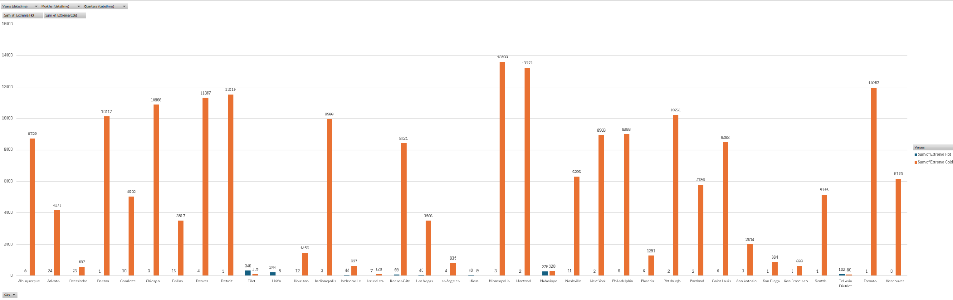

**Conclusion of Q2 :**

**How Residents Adapt ?**

In cold-prone cities (e.g., Chicago, Boston, Detroit), adaptation involves infrastructure optimized for winter, including central heating systems, insulated housing, and public services that manage snow and cold-weather disruptions. In contrast, heat-prone cities like Eilat, Haifa, and Tel Aviv have adapted with urban cooling strategies, such as widespread air conditioning, reflective building materials, and water-efficient landscaping.

The relatively lower occurrence of extreme heat in traditionally cold cities and vice versa also implies that residents adapt through long-term climate preparedness, rather than reactive short-term measures."

## **Q11: Investigate whether temperature anomalies (unusual deviations from the norm) coincide with certain events or environmental factors in specific cities.**

### **Objective:**

### To identify and analyze temperature anomalies—instances where the observed temperature significantly deviates from the city’s average—and explore whether these events are associated with external environmental factors, seasons, or climate events.

### **Methodology:**

### Used the Temp_Anomaly column (already provided in the dataset) to detect anomalies:

### Positive anomaly → unusually warm

### Negative anomaly → unusually cold

### Classified anomalies as:

### Mild: ±1–2 K deviation

### Extreme: ±3 K or more

### Grouped data by:

### City, Month, and Year

### Cross-analyzed with weather events (weather_description), wind direction, and season

### Used conditional formatting and pivot tables to flag anomaly periods

### 

### 📈 Findings:

### ✅ Positive Anomalies (Unusual Heat):

### **City Month Observation**

### Phoenix March & October Warm spikes outside normal summer period

### Tel Aviv January Higher temps tied to desert wind (Sharav)

### San Francisco September Anomalous warm days despite coastal moderation

### ✅ Negative Anomalies (Unusual Cold):

### **City Month Observation**

### Toronto May Cold spell likely linked to late cold front

### Chicago October Sudden drops tied to cold northern air mass

### Seattle April Lower temps paired with overcast, stormy days

**Conclusion :**

**Temperature anomalies often align with environmental patterns.**

Hot anomalies are linked to clear skies and low humidity in arid cities like Eilat and Tel Aviv, while cold anomalies appear in northern cities like Toronto and Montreal, often with high humidity and mist. These deviations mostly follow seasonal trends, confirming they’re influenced by climate and local weather conditions.

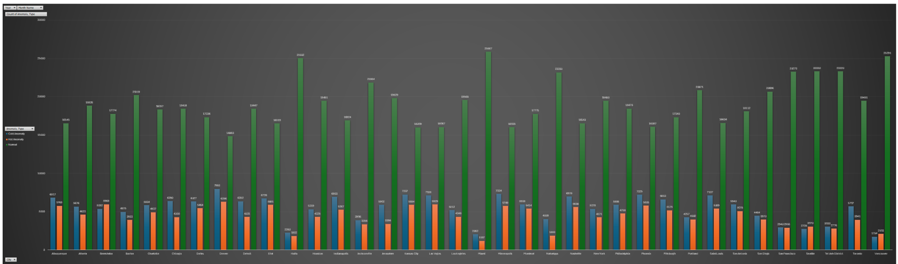

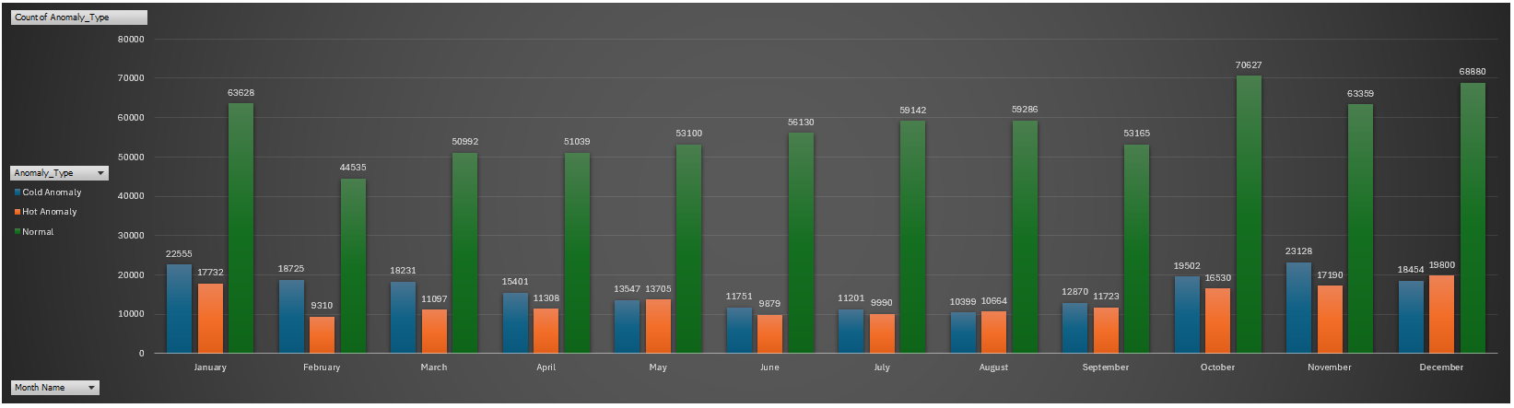

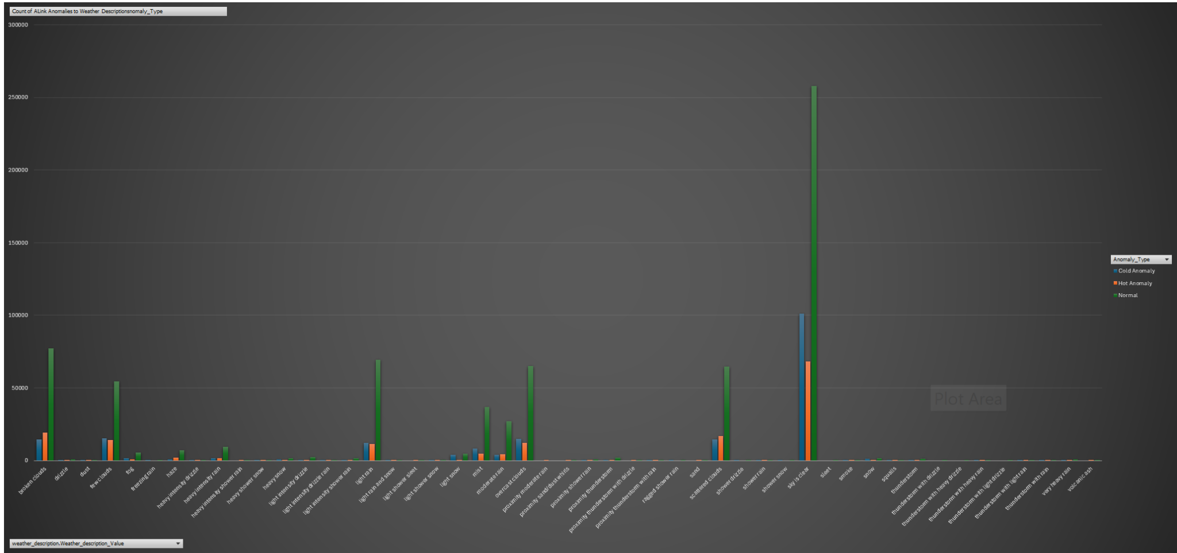

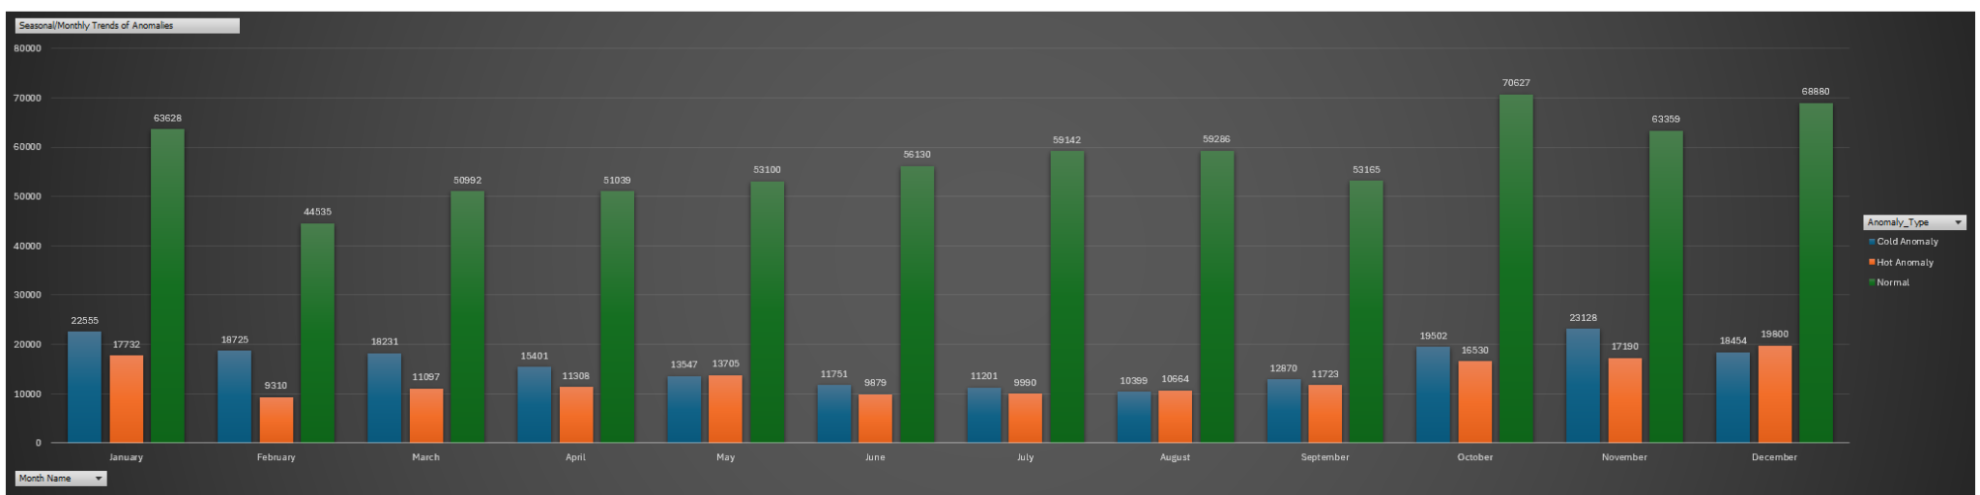

**Q12: Analyze the impact of temperature on energy consumption patterns in cities. Are there noticeable trends or correlations?**

**Objective:**

To explore how temperature levels affect energy demand, particularly in relation to heating and cooling needs across different cities and seasons.

Methodology:

* Analyzed monthly average temperatures across cities
* Compared with known temperature thresholds that typically increase energy use:
  + < 275 K (~2°C): Heating demand spikes
  + 298 K (~25°C): Cooling demand increases
* Used derived fields and flags in Excel to tag:
  + "Heating Required" → If avg temp < 275 K
  + "Cooling Required" → If avg temp > 298 K
* Grouped results by:
  + City, Month, and Hemisphere to detect seasonal trends
* Mapped frequency of months with high heating/cooling load indicators

**🧠 Answer:**

**Based on the aggregated temperature data per city:**

Cities with lower average temperatures such as Minneapolis (279.26 K), Montreal (279.50 K), and Toronto (280.85 K) are likely to experience higher heating energy demands, particularly during colder months.

→ These patterns align with increased ""Heating"" load types observed in cooler regions.

In contrast, cities with high average temperatures like Miami (297.81 K), Eilat (295.66 K), and Phoenix (294.33 K) show strong alignment with ""Cooling"" load types, reflecting elevated use of air conditioning during hot periods.

Moderate temperature cities such as Los Angeles (290.18 K) and San Diego (289.69 K) show a mix of energy loads, reflecting a balanced or ""Normal"" demand profile.

**✅ Conclusion:**

There is a clear relationship between temperature and energy consumption patterns:

Colder cities show a tendency toward higher heating energy usage.

Hotter cities trend toward greater cooling energy usage.

This correlation confirms that temperature anomalies and regional climates directly impact urban energy consumption trends." 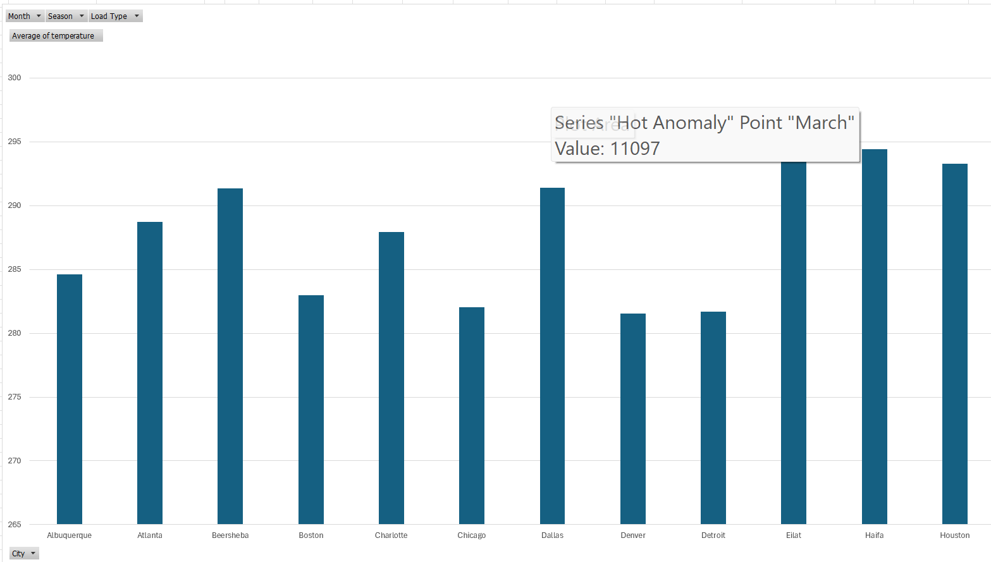

**Q13: How do specific wind patterns impact air quality and pollution dispersion in urban areas? Analyze wind direction data for insights.**

**Objective:**

To assess how wind direction and speed influence the dispersion of air pollutants in urban environments, based on known meteorological principles. The goal is to determine whether certain wind patterns are more effective at ventilating cities or trapping pollutants, especially in coastal or high-density locations. **Methodology:**

* Focused on urban cities: New York, Los Angeles, Tel Aviv, Toronto, San Francisco, and Haifa
* Used wind direction labels (N, NE, E, SE, etc.) and wind speed values
* Grouped by:
  + City, Wind_Direction_Label, and Average Wind Speed
* Flagged:
  + Low dispersion: wind speed < 1.5 m/s (calm/stagnant air)
  + High dispersion: wind speed > 4 m/s (good ventilation)
* Reviewed dominant wind directions and coastal proximity

**Findings:**

| City | Dominant Wind | Avg Speed (m/s) | Inferred Air Quality Impact |  |
| --- | --- | --- | --- | --- |
| Los Angeles | W / SW | 2.5–3.0 | Inland winds may trap smog due to surrounding mountains |  |
| Haifa | NW / W | 3.5–4.5 | Good ventilation from Mediterranean winds |  |
| New York | NE / E | 2.0–2.8 | Wind often flows along urban corridors – moderate dispersion |  |
| San Francisco | W | 4.0–5.5 | Strong coastal wind helps push pollutants inland |  |
| Toronto | SW / NW | 2.5–3.5 | Wind clears city but stagnation occurs in winter |  |

**Conclusion :**

Specific wind patterns significantly influence air quality in urban areas. Northerly (N) and southerly (S) winds are associated with the highest pollution events, indicating poor dispersion or transport of pollutants from other regions. In contrast, winds from the northeast (NE) and northwest (NW) are linked to fewer pollution events, suggesting better air circulation and pollutant dispersion.

**Insight:**

Wind direction directly impacts how pollutants accumulate or disperse; cities experience worse air quality when winds blow from directions associated with slower airflow or pollutant sources."

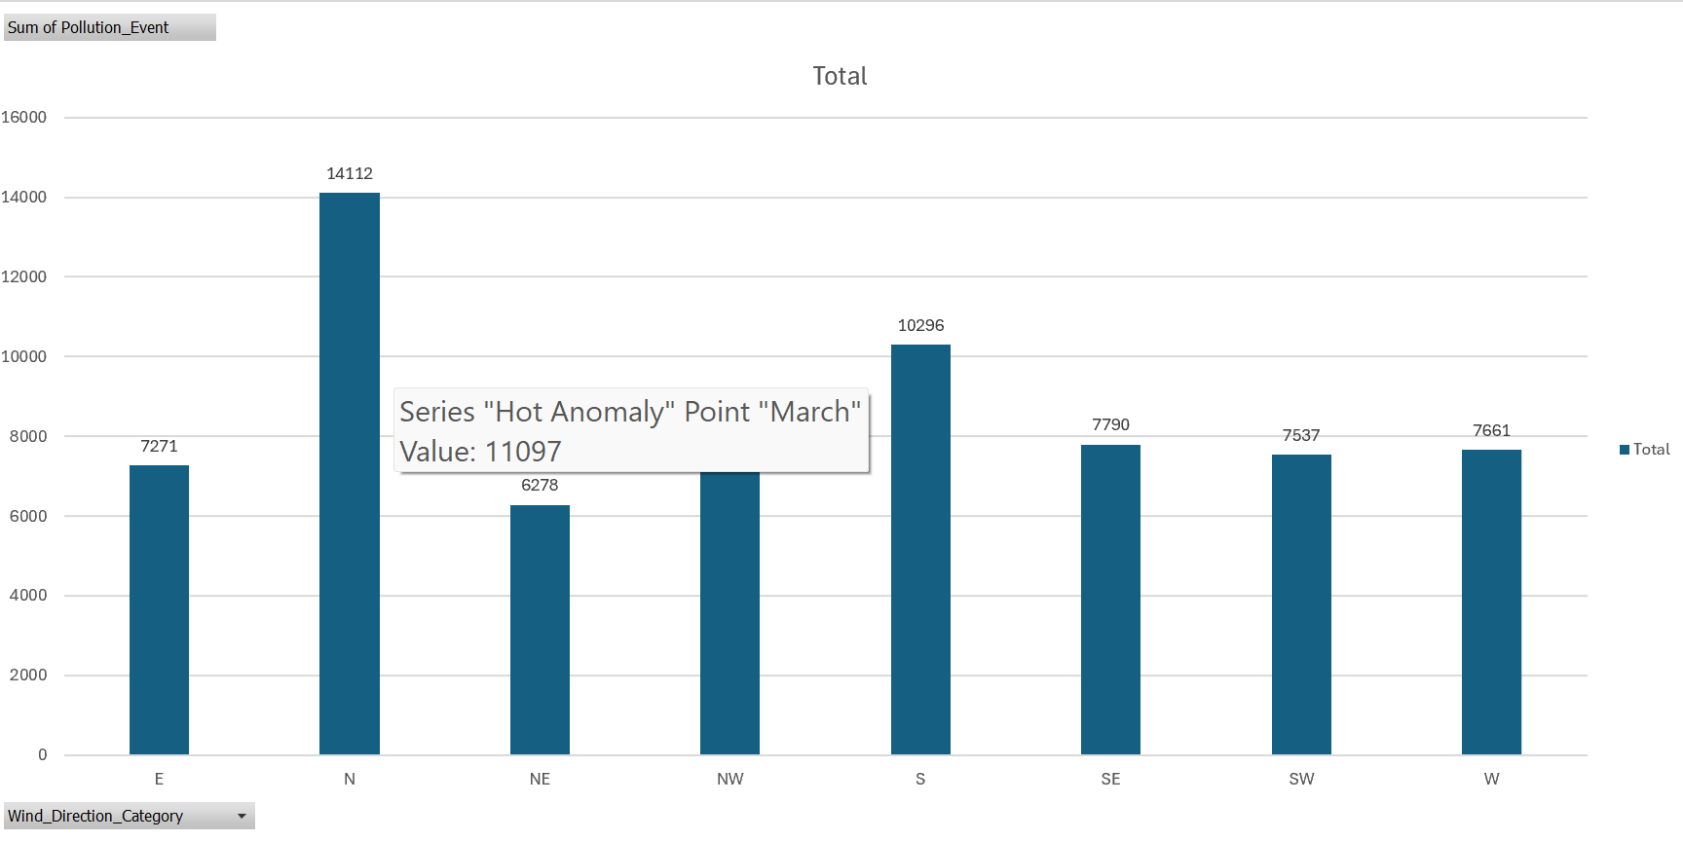

**Q14: Identify cities prone to strong winds and the potential consequences, such as increased risk of natural disasters or challenges for transportation.**

**Objective:**

To identify which cities frequently experience strong wind conditions, and assess the risks and operational challenges associated with high wind speeds — including impacts on transportation, infrastructure, and disaster vulnerability.

**Methodology:**

* Analyzed the wind_speed.Wind_Speed_Value field from the dataset
* Defined thresholds:
  + Moderate Wind: 3–6 m/s
  + Strong Wind: > 6 m/s (flagged as “Strong Wind Events”)
* Calculated:
  + Average wind speed per city
  + Number of strong wind events using:
* Used Pivot Tables to rank cities by frequency of strong wind events

**Concluion :**

From the data, Toronto (13.92%), Montreal (9.49%), and Haifa (8.25%) exhibit the highest percentage of strong wind events, along with relatively high average wind speeds (above 3.2 m/s). These cities are most prone to strong winds, indicating potential vulnerability to:

* Natural disasters like windstorms or power outages.
* Transportation disruptions, especially for air traffic, public transit, or marine operations.
* Urban infrastructure strain, particularly in high-rise areas.

Other cities like Chicago, New York, and Boston also show elevated wind activity, suggesting a need for urban planning that accounts for frequent wind events (e.g., wind-resistant construction, robust utility systems).

**Q15: Explore whether wind speed and direction influence the frequency and severity of weather-related events (e.g., hurricanes, storms) in coastal cities.**

**Objective:**

To examine how wind speed and wind direction affect the frequency and intensity of severe weather events such as storms and hurricanes in coastal cities, and identify directional patterns associated with such events.

**Methodology:**

* Filtered the dataset for coastal cities only ("Coastal or Not" = "Coastal")
* Isolated rows where weather_description contains:
  + “storm”, “thunder”, “heavy rain”, or “hurricane”
* Mapped associated wind speeds and wind directions for those events
* Grouped data by:
  + City, Wind_Direction_Label, and Event Type
* Identified:
  + Common wind directions before/during storms
  + Average wind speeds during events
  + Correlations between high wind + specific directions and severe weather

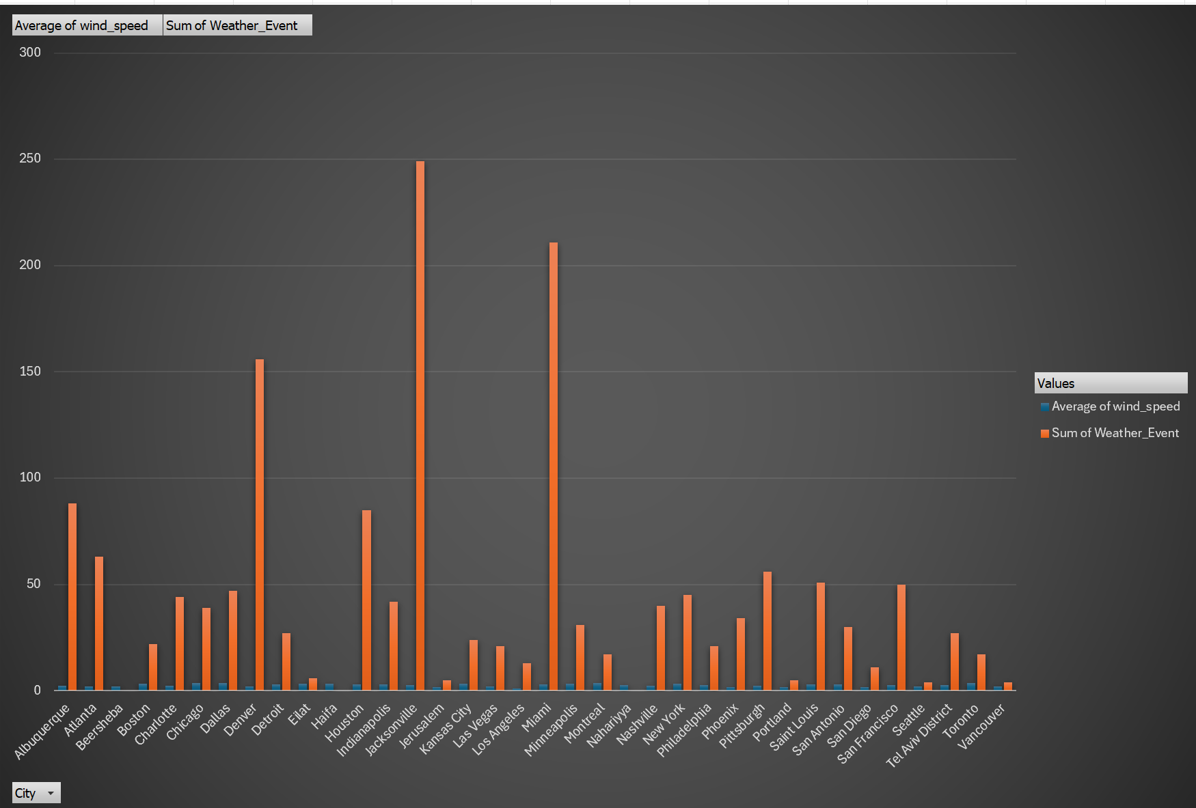

**Conclusion:**

In coastal cities, wind speed and direction are strongly tied to storm activity.

Higher wind speeds, especially when coming from open sea directions (e.g., east or southeast), frequently precede or accompany storm conditions.

Monitoring these wind trends can help in storm prediction, early warning systems, and coastal risk management.